**Project Design Phase-II**

**Technology Stack (Architecture & Stack)**

|  |  |
| --- | --- |
| Date | 20 October 2022 |
| Team ID | PNT2022TMID05265 |
| Project Name | Smart Farmer – IoT Enabled Smart Farming Application |
| Maximum Marks | 4 Marks |

**Technical Architecture:**

The Deliverable shall include the architectural diagram as below and the information as per the table1 & table 2

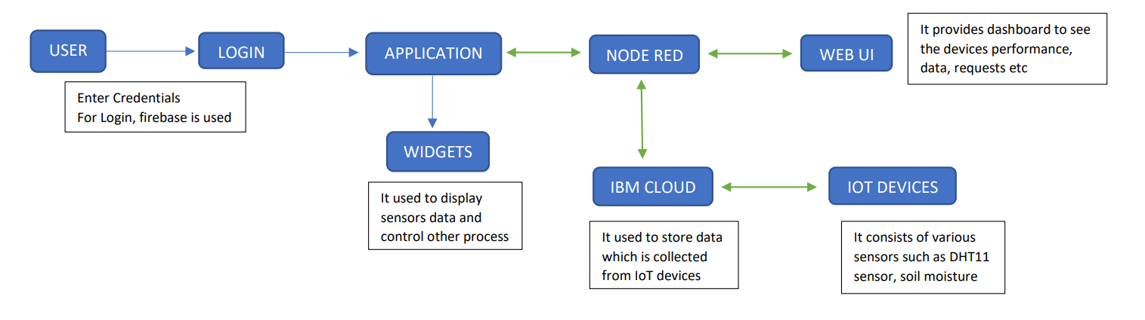

**Table-1: Components & Technologies:**

|  |  |  |  |
| --- | --- | --- | --- |
| **S.No** | **Component** | **Description** | **Technology** |
| 1 | User Interface | Mobile app. In our application where data are displayed using widgets like structure. Users interacts with widgets to additional info | MIT App Inventor |
| 2 | Application Logic-1 | Logic for a process in the application | Python |
| 3 | Application Logic-2 | Logic for a process in the application | IBM Watson STT service |
| 4 | Application Logic-3 | Logic for a process in the application | IBM Watson Assistant |
| 5 | Database | Data base type | Firebase is Nosql database |
| 6 | Cloud Database | Database Service on Cloud | Firebase, IBM Watson IoT Cloud Platform |
| 7 | File Storage | File storage requirements | IBM Block Storage or Other Storage Service or Local Filesystem |
| 8 | External API-1 | Purpose of the API is get to weather information | Open Weather API |
| 9 | External API-2 | Purpose of the API is to connect with firebase for login purpose | Firebase API |
| 10 | Infrastructure (Server / Cloud) | Application Deployment on Local System / Cloud  Local Server Configuration:  Cloud Server Configuration: | Local, IBM Cloud, Firebase |
| 11 | DHT11 sensor, Soil Moisture sensor | It used to monitor the soil, temperature, humidity. |  |

**Table-2: Application Characteristics:**

|  |  |  |  |
| --- | --- | --- | --- |
| **S.No** | **Characteristics** | **Description** | **Technology** |
| 1 | Open-Source Frameworks | Node Red, MIT App Inventor, Arduino IDE Node Red for connecting with application, MIT App Inventor for building app, Arduino is open-source electronics platform to build hardware and software. | It is a software, which helps in connecting and building application. Node Red, MIT App Inventor, Arduino IDE. |
| 2 | Security Implementations | HTTPS Connections, X-Force Red IoT Testing | Encryptions, Secured Connection |
| 3 | Scalable Architecture | Architecture is scalable from 10 devices to 300 devices easily and account is also scalable up to thousand connections. For very high scalability we need to upgrade our cloud plan. | Firebase, IBM Cloud |
| 4 | Availability | Availability of our application is 24/7 because which use a cloud technology. Firebase will use commercially reasonable efforts to make Firebase available with a Monthly Uptime Percentage of at least 99.95% and distributed servers. | Firebase, IBM Cloud |
| 5 | Performance | No of requests is 2 requests per 20 seconds or 4 requests per 30 second and sometimes user request will be added with respective to the requests | MIT App Inventor, Node Red, Cloud |